**INTELLIGENT HOSIPTAL MANAGEMENT SYSTEM**

A Project Report

Submitted in the Completion of the course

Enterprise Programming

# in

Department of Computer Science and Engineering

By

KOTA MANIDEEP REDDY (2010030309)

I KAUSTUBH SASTRY (2010030064)

M ABHIRAM (2010030457)

K.V. MANOHAR KARTHIK

under the supervision of

Dr. G. Madhukar Rao

Assistant Professor



Department of Computer Science and Engineering

K L University Hyderabad,

Aziz Nagar, Moinabad Road, Hyderabad – 500 075, Telangana, India.

November, 2022

**DECLARATION**

The Project Report entitled “**INTELLIGENT HOSIPTAL MANAGEMENT SYSTEM**” is a record of the bonafide work of KOTA MANIDEEP REDDY(2010030309), I KAUSTUBH SASTRY(2010030064), M. ABHIRAM(2010030457), K.V.MANOHAR KARTHIK, submitted in partial fulfillment for the award of B.Tech in the Department of Computer Science and Engineering to the K L University, Hyderabad. The results embodied in this report have not been copied from any other Departments/universities/institutes.

KOTA MANIDEEP REDDY (2010030309)

I KAUSTUBH SASTRY

(2010030064)

M.ABHIRAM  
(2010030457)

K.V.MANOHAR KARTHIK

(2010030197)

**CERTIFICATE**

This is to certify that the Project Report entitled “**INTELLIGENT HOSIPTAL MANAGEMENT SYSTEM**” is being submitted by KOTA MANIDEEP REDDY(2010030309), I KAUSTUBH SASTRY(2010030064), M ABHIRAM (2010030457), K.V.MANOHAR KARTHIK submitted in partial fulfillment for the award of B.Tech in CSE to the K L University, Hyderabad is a record of bonafide work carried out under our guidance and supervision. The results embodied in this report have not been copied from any other departments/universities/institutes.

## Signature of the Supervisor

Dr. G. Madhukar Rao

Assistant Professor

## Signature of the HOD Signature of the External Examiner

**ACKNOWLEDGEMENT**

First and foremost, we thank the lord almighty for all his grace & mercy showered upon us, for completing this project successfully.

We take grateful opportunity to thank our beloved **Founder and Chairman** who has given constant encouragement during our course and motivated us to do this project. We are grateful to our Principal **Dr. L. Koteswara Rao** who has been constantly bearing the torch for all the curricular activities undertaken by us.

We pay our grateful acknowledgment & sincere thanks to our Head of the Department

**Dr. Chiranjeevi Manike** for her exemplary guidance, monitoring and constant encouragement throughout the course of the project. We thank **Dr. G Madhukar Rao** of our department who has supported throughout this project holding a position of supervisor.

We whole heartedly thank all the teaching and non-teaching staff of our department without whom we won’t have made this project a reality. We would like to extend our sincere thanks especially to our parent, our family members and friends who have supported us to make this project a grand success.

**ABSTRACT**

Technology has improved immensely in recent days. Improving the quality of one’s life is an important benefit of technology in healthcare. Besides, it also reduces the burden of staff in the hospital and improves the health of the patient easily and efficiently.

The three keys in the healthcare sector are

• Technological enablement

• Digitization

• Automation

This transformation with the Hospital Management System switches traditional hospitals into Smart Hospitals. Moreover. Smart hospitals have the potential for exponential growth.

Smart Hospitals are in high demand in the 21st century. The market value of smart hospitals accounted for 22.2 billion USD in 2018. However, in 2021, it has risen to 35.9 billion USD. Moreover, the estimated market value in 2026 is 83.1 billion USD!!! Thus, technology is essentially a catalyst in the healthcare industry. (Source: Statista)

**TABLE OF CONTENTS**

|  |  |  |
| --- | --- | --- |
| **S.NO** | **CONTENTS** | **PAGE.NO** |
| **1.** | **Existing Work** | **4** |
| **2.** | **Problem Statement** | **5** |
| **3.** | **Proposed Work** | **5** |
| **4.** | **Hardware & Software requirements**  **4.1. Hardware requirements**  **4.2. Software requirements** | **6** |
| **5.** | **Hospital Management System** | **7** |
| **6.** | **Modules** | **8** |
| **7.** | **Results and Discussion**   * **7.1 Home Page** * **7.2 Admin Login Page** * **7.3 Admin Dashboard** * **7.4 Doctor Login Page** * **7.5 Doctor Dashboard** * **7.6 Patient Login Page** * **7.7 Patient Dashboard** | **9** |
| **8.** | **Conclusion and Future Enhancement**  **8.1 Conclusion**  **8.2 Future Work** | **10** |
| **9.** | **References** | **11** |

**1. EXISTING WORK**

**LITERATURE SURVEY**

1. “**A hospital resource and patient management system based on real-time data capture and intelligent decision making**” **Author(s)**: Musa, A. Lancashire Bus. Sch., Univ. of Central Lancashire, Preston, UK Yusuf, Y, Meckel.M. Systems and Informatics (ICSAI), 2012 International Conference

One of themajor challenges existing hospital management systems face is around operational efficiency and wait times between different processes, departments and persons. This paper highlights such limitations of existing systems and proposes a RFID(Radio Frequency ID) and wireless sensor based , location and information management framework that facilitates real time tracking of hospital assets, personnel and patients as they move through pre-set procedures as part of daily activities of the hospitals

2.“**Study on information system of health care services management in hospital**”

Author(s): Daiping Hu, Antai Sch. of Manage., Shanghai Jiaotong Univ., China Weiguo Xu ; Huizhang Shen ; Mengyu Li. Services Systems and Services Management, 2005. Proceedings of ICSSSM '05. 2005 International Conference .

This paper reviews the HIS (Hospital Information Systems) which are widely used in many hospitals in China mainly to provide easier and faster way for daily medical tasks /activities with a GUI And provides for overcoming some of the limitations of HIS , eg. HIS aims at improving quality of health care services but do not have way of evaluating /measuring those. So this paper proposes HSMS (Hospital Services Management System) which aims at improving quality of services, identifying cost reduction areas , analyses and evaluate /rate heath care services .

3.“**Developing Effective Hospital Management Information Systems: A Technology Ecosystem Perspective**”.

Authors: Dr Christopher Bain MBBS, Master Info.

The author of this paper focuses more on needs of hospital manager and the ecosystem in which he/she operates. The internal and external Environment shaping factors ESFs that bear an impact or association on daily hospital activities and decision-making process that the hospital manager has to go through in each situations. Some of the challenges that this ecosystem needs to work on are high demand pressure, greater customer satisfaction level and low profit margins. This paper more so contributes to Planning, Design and development aspects of any Hospital management system by highlighting ESFs that should be considered

5

## 2. PROBLEM STATEMENT

Hospitals faced many complications due to poor management of paper works. Improper documentation of patient data across various departments is a confidential matter. However, the hospital Management system automates the management and reduces the paperwork. Thus, it not only reduces the burden on staff but also makes documentation easier.

Hospital management software maintains patient medical records along with contact details

It tracks the schedules of surgeries, check-ups, and others

Maintains insurance records for reference purposes

Easy tracking of bills

**3. PROPOSED WORK**

A hospital Information Management System is an electronic record of all the details. Besides, this hospital information management system contains crucial information such as clinical test reports and billing details.

The Hospital Management system software mainly focuses on administrative works. Besides, this integrated hospital management system software takes care of the financial and legal operations of the firm. Thus, it is a common source of hospital information.

**Advantages**:

The main advantage of this hospital information management system is it eliminates the risk of “lost files”. However, it provides access only to authorized users. Thus, the hospital information management system ensures high security.

On the other hand, a hospital information management system reduces labor and seamlessly manages patient data. This data can be accessed across healthcare firms, beyond physical borders.

**3.1 Objective:**

The main objective of this Intelligent Hospital application is to save time of both patient and the doctor. To provide a quick exploration of the disease. This application provides a search option to the doctor where he can get the result very quickly by selecting the symptoms of the patient. This application provides a graph with the details of levels of the disease in various locations.

**4. HARDWARE & SOFTWARE REQUIREMENTS:**

**4.1 HARDWARE REQUIREMENTS**

* Operating System: Any operating system.
* Processor: Intel Core i5 7th Gen 2.50GHz.
* RAM: 8 GB.

# **4.2 SOFTWARE REQUIREMENTS:**

# Operating System : windows 10,11 later

# Web Server : Tomcat version 10

# Database server : My SQL ,Access

# Runtime Environment :Java Runtime Environment 5.0

# Development tools: Eclipse, IntelliJ idea

# Web Browser : chrome ,edge ,Firefox, brave

1. **HOSPITAL DATABASE MANAGEMENT SYSTEM**

Hospital Database Management System

Generally, people shortlist the hospitals by considering the management. Hospital Database Management System helps to provide good medical assistance. Further, a doctor provides care for multiple patients. Hence, it is necessary to know all the related details. This is where Hospital Database Management System is beneficial.

The two main hospital database management system types are:

1. Patient Database management: All the details of the patients, including name, contact details, treatment details are recorded.
2. Staff Database management: Details of all the staff are stored here. It includes doctors, nurses, security staff, office desk staff, and others**.**
3. **MODULES**

A Smart Hospital management system improves diagnosis and treatment for the patient. Further, a detailed understanding of the patient provides a deeper insight. Thus, a smart hospital management system supports evidence-based treatments.

Furthermore, the seamless functioning of the hospital provides patients with a glitch-free experience. Also, the smart hospital management system ensures proper working order to achieve optimum results. On the other hand, the departmental collaboration with a smart hospital management system ensures scalability and integrated patient care.

**Doctor:**

Doctor can register by entering the information. He can get login by entering the unique username and password. Doctor can add patient details, search the disease by selecting the symptoms and he can view the graph of the disease levels in various locations.

**Admin Login:**

The admin is holding the credentials for the website , using which we can monitor the whole activities of the website .Master access to the other modules

**User/patient login:**

The patient login provides the interface to interact with the doctors ask their queries and upload their documents .

1. **RESULTS & DISCUSSION**

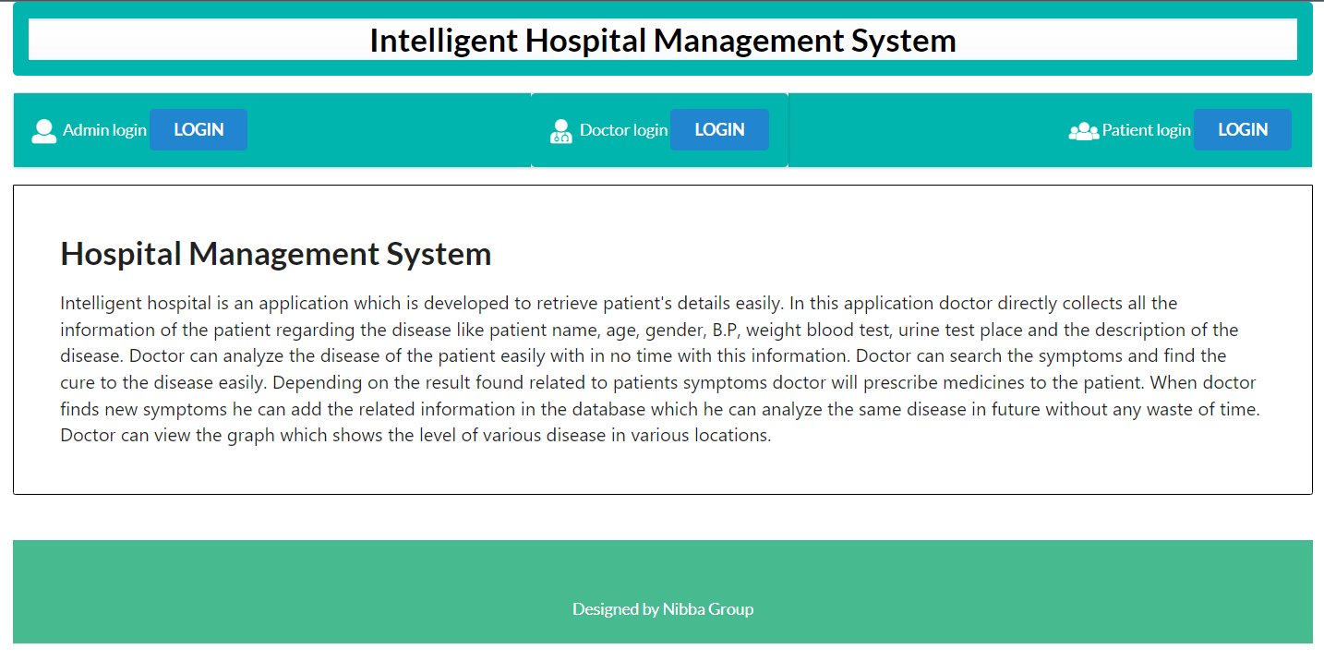

**Fig: 7.1 Home Page**

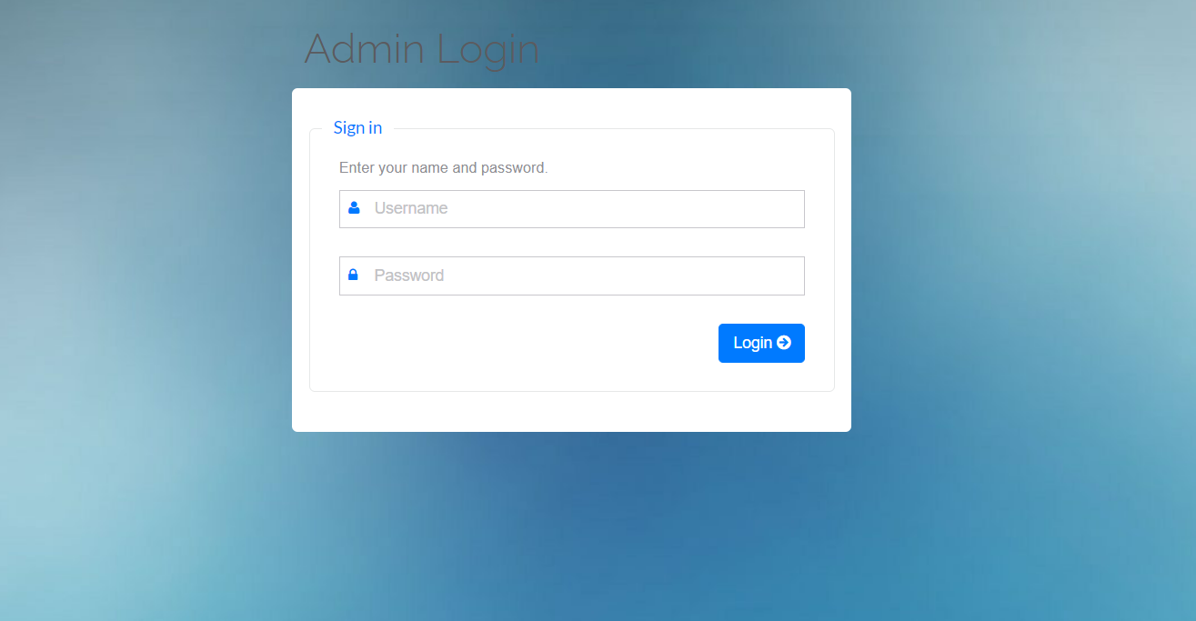

**Fig: 7.2** **Admin Login Page**

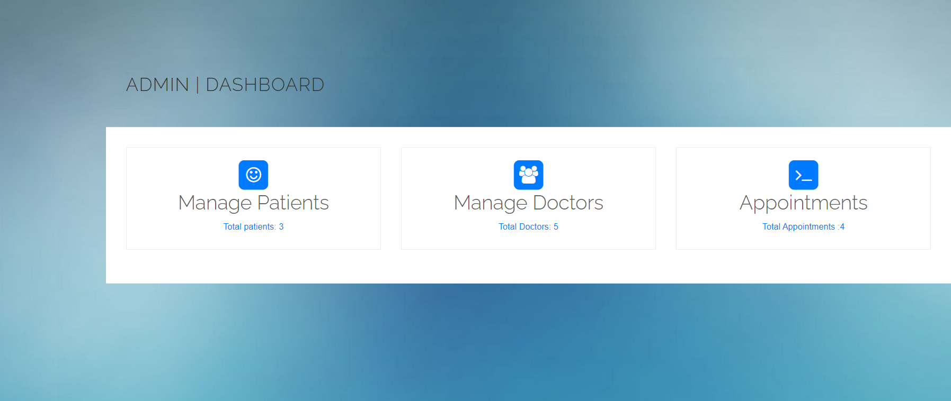

**Fig: 7.3 Admin Dashboard**

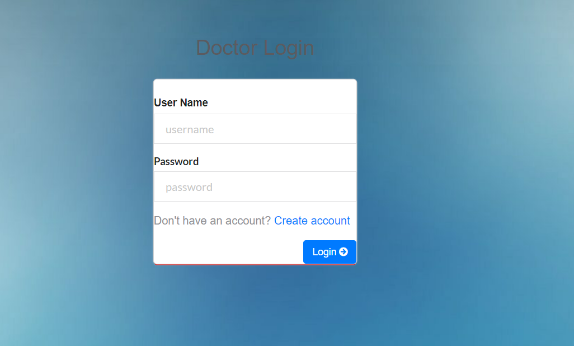

**Fig: 7.4 Doctor Login Page**

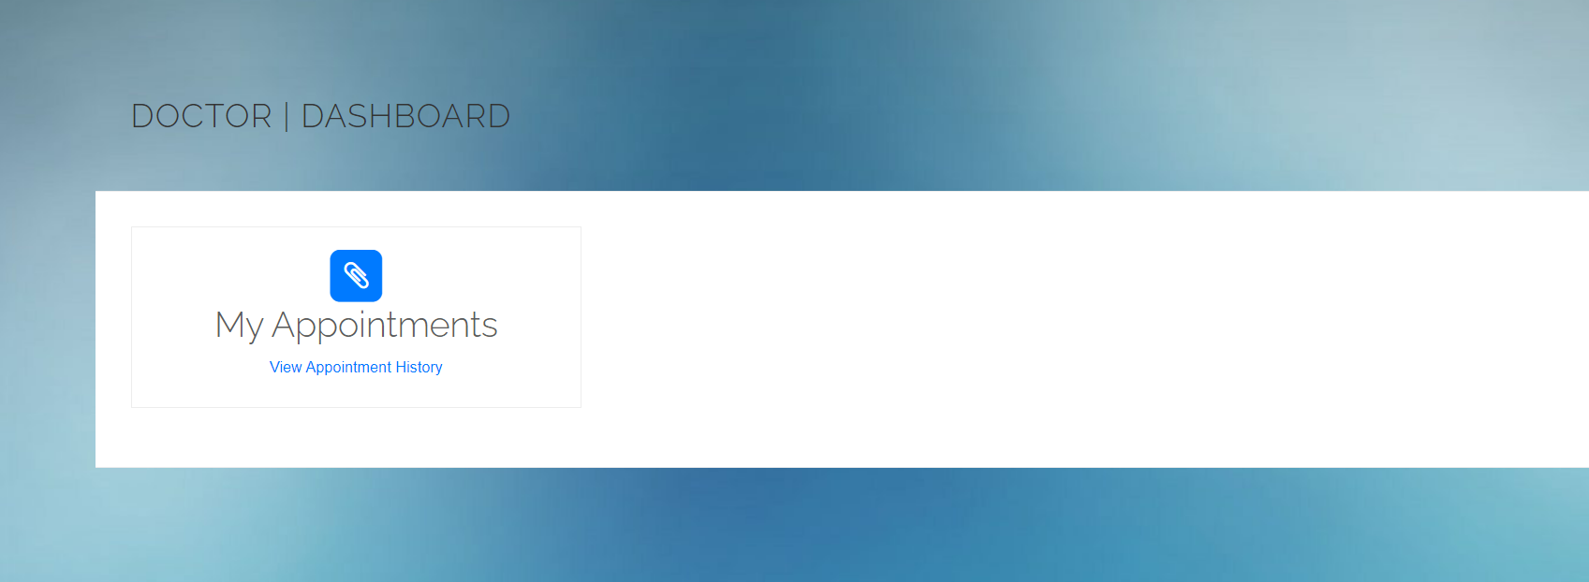

**Fig: 7.5 Doctor Dashboard**

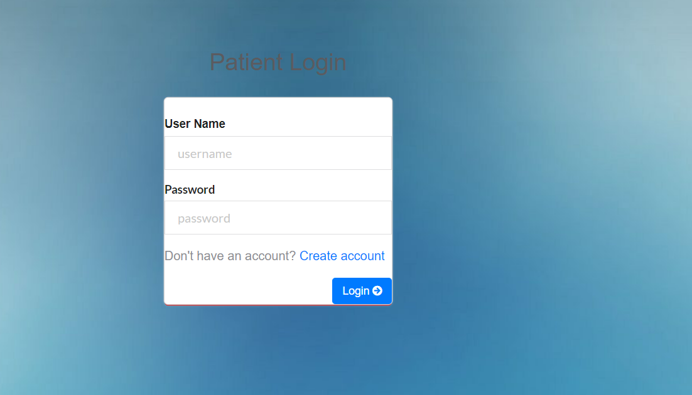

**Fig: 7.6 Patient Login Page**

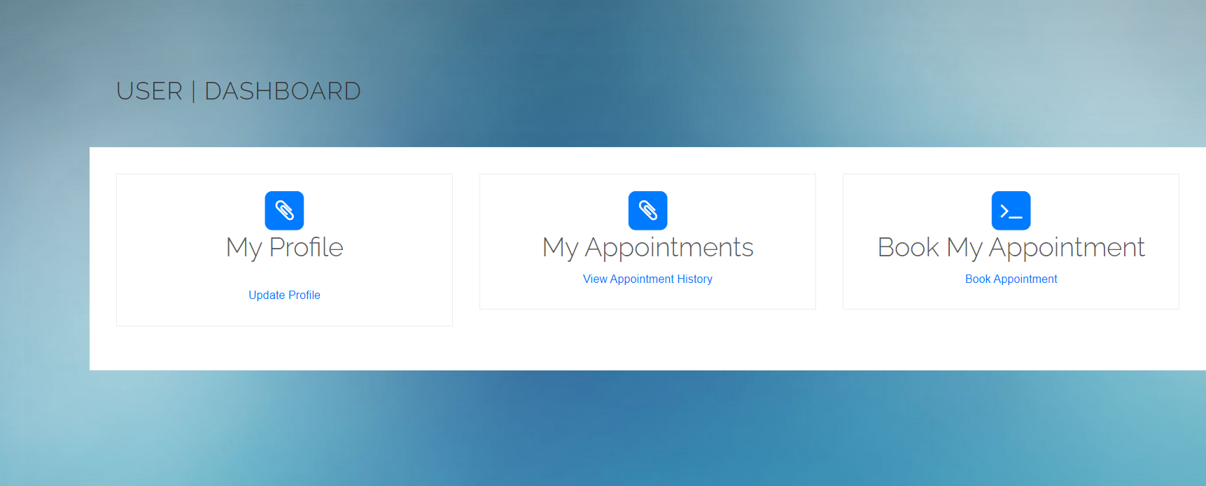

**Fig: 7.7 Patient Dashboard**

**8. CONCLUSION AND FUTURE WORK**

**8.1 Conclusion**

Our application “Intelligent Hospital” maintains all the patient’s information and the disease details securely. Using this application patient details can be retrieved easily. This application guarantees the accurate maintenance of the patient details and gives the cure to the symptoms of the patient in very less time.Doctor can find the treatment to the symptoms of the patient by clicking on the search button which saves lot of time. This application also provides graph for various diseases in various locations.

Advantages of this system:

1. Digital medical records reduce the errors and records each data in detail
2. Provides easy access to patient history
3. Improves efficiency of the staff
4. Manages hospital facilities efficiently
5. The use of technology reduces the time-consumption
6. Hospital management software is cost-effective and helps in tax planning
7. Hospital management system software improves market strategies and provides better financial control
8. Enhanced [patient care](https://www.cronj.com/blog/how-does-virtual-specialty-care-scale-patient-care/)

The main advantage of this hospital information management system is it eliminates the risk of “lost files”. However, it provides access only to authorized users. Thus, the hospital information management system ensures high security.

On the other hand, a hospital information management system reduces labor and seamlessly manages patient data. This data can be accessed across healthcare firms, beyond physical borders.

**8.2 Future Work**

We are working on enhancing the work we completed by adding numerous modules to the work, we are trying to build a whole new virtual hospital system. We are planning on adding the following modules to it:

**Lab Management:**

Handle your orders, automate report generations, enable smart notifications. Further, switch to analytical reports with an online Hospital management system.

**Improve Customer Services:**

Customer service is meeting the needs and requirements of the customer. The ultimate goal of hospital management software is to provide accurate and complete information or data at once. Thus, HMS increases customer support services.

**OT Management:**

Check the OT availability with the online Hospital management system. Thus, automate operation scheduling and make use of Operation theatres efficiently.

**9. REFERENCES**

[1] Koyuncu, Baki, and Hakan Koyuncu. "Intelligent Hospital Management System (IHMS)." In *2015 International Conference on Computational Intelligence and Communication Networks (CICN)*, pp. 1602-1604. IEEE, 2015.

[2] Liaqat, Rao Muzamal, Ali Athar, and Nazar Abbas Saqib. "Intelligent agent based system for monitoring and control of hospital management system." In *2015 2nd International Conference on Information Science and Security (ICISS)*, pp. 1-5. IEEE, 2015.

[3] Ponmalar, A., S. Maansi, S. Mahalakshmi, M. Shalini, and Rinthya Madhavan. "Mobile Application for Hospital Management System." In *2021 5th International Conference on Intelligent Computing and Control Systems (ICICCS)*, pp. 1434-1437. IEEE, 2021.

[4] Kushwaha, Nidhi, Shashank Sahu, and Rajesh Kumar Tyagi. "Evolving intelligent agents for hospital management system." In *2013 3rd IEEE International Advance Computing Conference (IACC)*, pp. 899-907. IEEE, 2013.

[5] Mosadeghrad, Ali Mohammad, and Mahdi Abbasi. "Managerial intelligence of hospital managers in Sari, Iran." *Management Strategies in Health System* 4, no. 4 (2020): 281-294.